Machine Learning 2025W — Exercise 0
Group members: Weber Benjamin, Donner Adrian, Florian Hess

Dataset 1: Heart Disease

Introduction
We selected the Heart Disease dataset as our first dataset because it is a real-world medical dataset, making it particularly interesting, and it supports classification tasks, since the target variable is categorical. The dataset contains both numerical and categorical variables. Furthermore, the dataset offers opportunities for multiple preprocessing steps, including handling NA values and scaling. With its 303 instances and 76 attributes, where 13 are suggested for use, it offers a manageable dataset size, making it possible to try different models without incurring significant time expenses

Target attribute:
The target attribute in the Heart Disease dataset is the presence of heart disease in the patient named num. The target variable can be expressed on an ordinal categorical scale from 0 to 4, where 0 indicates the absence of heart disease and values from 1 to 4 indicate its presence.
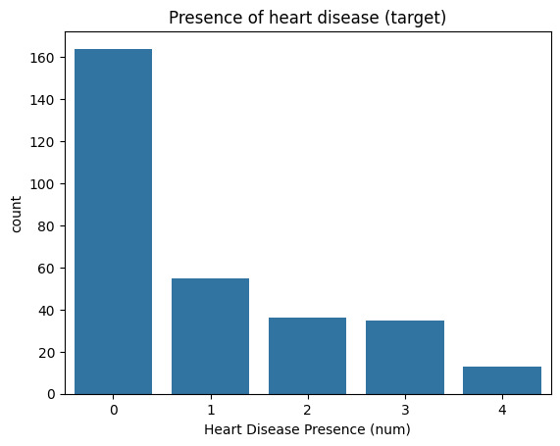

Input attributes:

Numeric values:
Interval Scale: age, trestbps, chol, thalach, oldpeak, ca
Ratio Scale: -
We identified ca as an interesting ratio attribute in relation to heart disease, since it has the highest correlation with num. CA describes the number of major vessels colored by fluoroscopy
Correlation | num
num | 1.0
ca | 0.5189092469193571
oldpeak | 0.504091973033799
Age | 0.222853419275953
trestbps | 0.1577540762636873
chol | 0.07090875545132243
thalach | -0.41504046173507825

Categorical values:
Nominal: sex, fbs, exang, slope, thal
Ordinal: cp, restecg
As an interesting categorical value, we choose restecg, which describes the resting electrocardiographic results in the three categories “normal”, “having ST-T wave abnormality”, and “showing probable or definite left ventricular hypertrophy”. By examining this attribute, we can also observe that the first and third categories are highly dominant. In the whole dataset, there are just four patients “having ST-T wave abnormality”.

Dataset 2: Adult Income

Introduction
We selected the Adult Income dataset as our second dataset. This is a large-scale dataset containing nearly 50,000 instances with 15 attributes. The attributes are a mix of numerical and categorical values, including several with missing values that require preprocessing. We can also demonstrate other preprocessing techniques, such as encoding categorical variables and scaling numerical features, with this dataset. As the dataset is relatively large, model training takes more time; however, it also provides statistically robust model training and comparison.

Target attribute:
The target attribute in the Adult dataset is the presence of a person making over 50k a year. The target variable can be expressed on a binary (categorical) scale from 0 to 1, where 0 indicates a person making less than 50k a year and 1 indicates a person who makes over 50k a year.
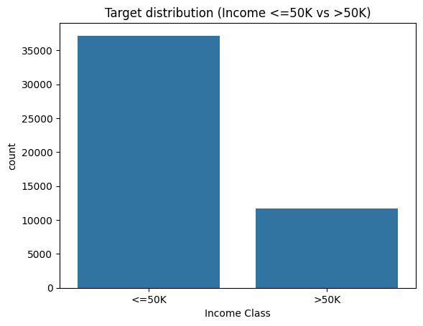

Input attributes:

Numeric values:
Interval Scale: fnlwgt, education-num
Ratio Scale: age, capital-gain, capital-loss, hours-per-week
We identified capital gain as an interesting variable in this dataset, as it shows some far outlier values, which can potentially influence our model.
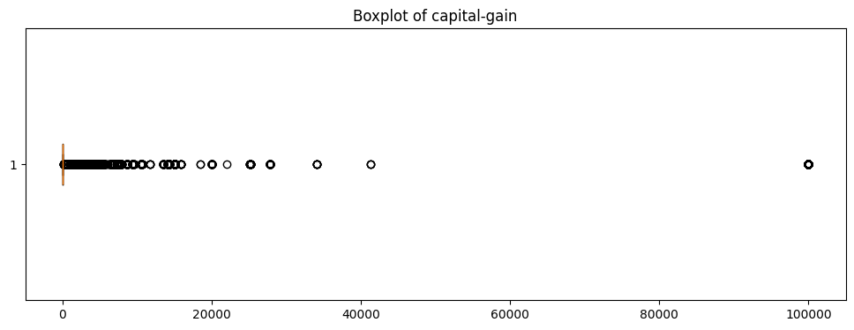

Categorical values:
Nominal: sex, workclass, education, occupation, relationship, race, native-country
Ordinal: -
The native-country is a particularly interesting variable here. The data shows that, by far, the largest native-country represented in the dataset is the US, which is very important later for the interpretations and limitations of the outcomes.

